Assignment 2

Deadline: Day 19/3/2017 @ 23:59

**[Total Mark for this Assignment is 4]**

***IT Project Management***

***IT270***

**Instructions:**

* This Assignment must be submitted on Blackboard via the allocated folder.
* Email submission will not be accepted.
* You are advised to make your work clear and well-presented, marks may be reduced for poor presentation.
* You MUST show all your work.
* Late submission will result in ZERO marks being awarded.
* Identical copy from students or other resources will result in ZERO marks for all involved students.
* This is an individual assignment.

Student Details:

|  |  |  |
| --- | --- | --- |
|  |  |  |
| **Name:** Munirah Alrushud  **CRN:** 21436 |  | **ID:** 140032004 |
|  |  |  |

**Course Registration Project**

***“Simple Scenario”***

* **At the beginning of each semester, students get a course catalogue containing a list of course offerings for the semester. Information about each course, such as professor, department, and prerequisites will be included to help students make informed decisions.**
* **The system will allow students to select four course offerings for the coming semester. In addition, each student will indicate two alternative choices in case the student cannot be assigned to a primary selection.**
* **Course offerings will have a maximum of ten students and a minimum of three students.**  **A course offering with fewer than three students will be cancelled. Once the registration process is completed for a student, the registration system sends information to the billing system so the student can be billed.**
* **Professors must be able to access the online system to indicate which courses they will be teaching. They will also need to see which students signed up for their course offerings.**
* **For each semester, there is a period of time that students can change their schedule. Students must be able to access the system during this time to add or drop courses.**

***Please read the simple scenario carefully for the project, and answer the following questions:***

# Question One

***2 Marks***

*Learning Outcome(s):*

* Identify the elements used when developing project management plans.
* Describe the tools and techniques used for directing and implementing projects.
* Discuss the different ways in which project work is monitored and controlled
* Review an organizational case study which incorporates elements for managing a project from start to finish.

Using Microsoft Project 2007/2010 tool, draw Gantt Chart for “*Course Registration Project*” showing the task name and the duration of each task (Work Breakdown Structure (**WBS**))?

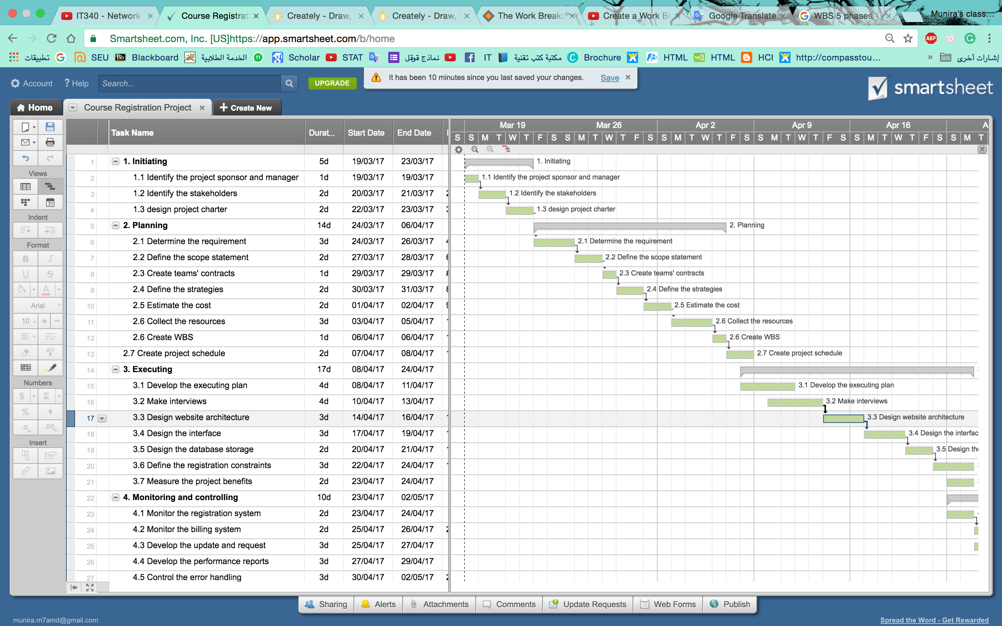

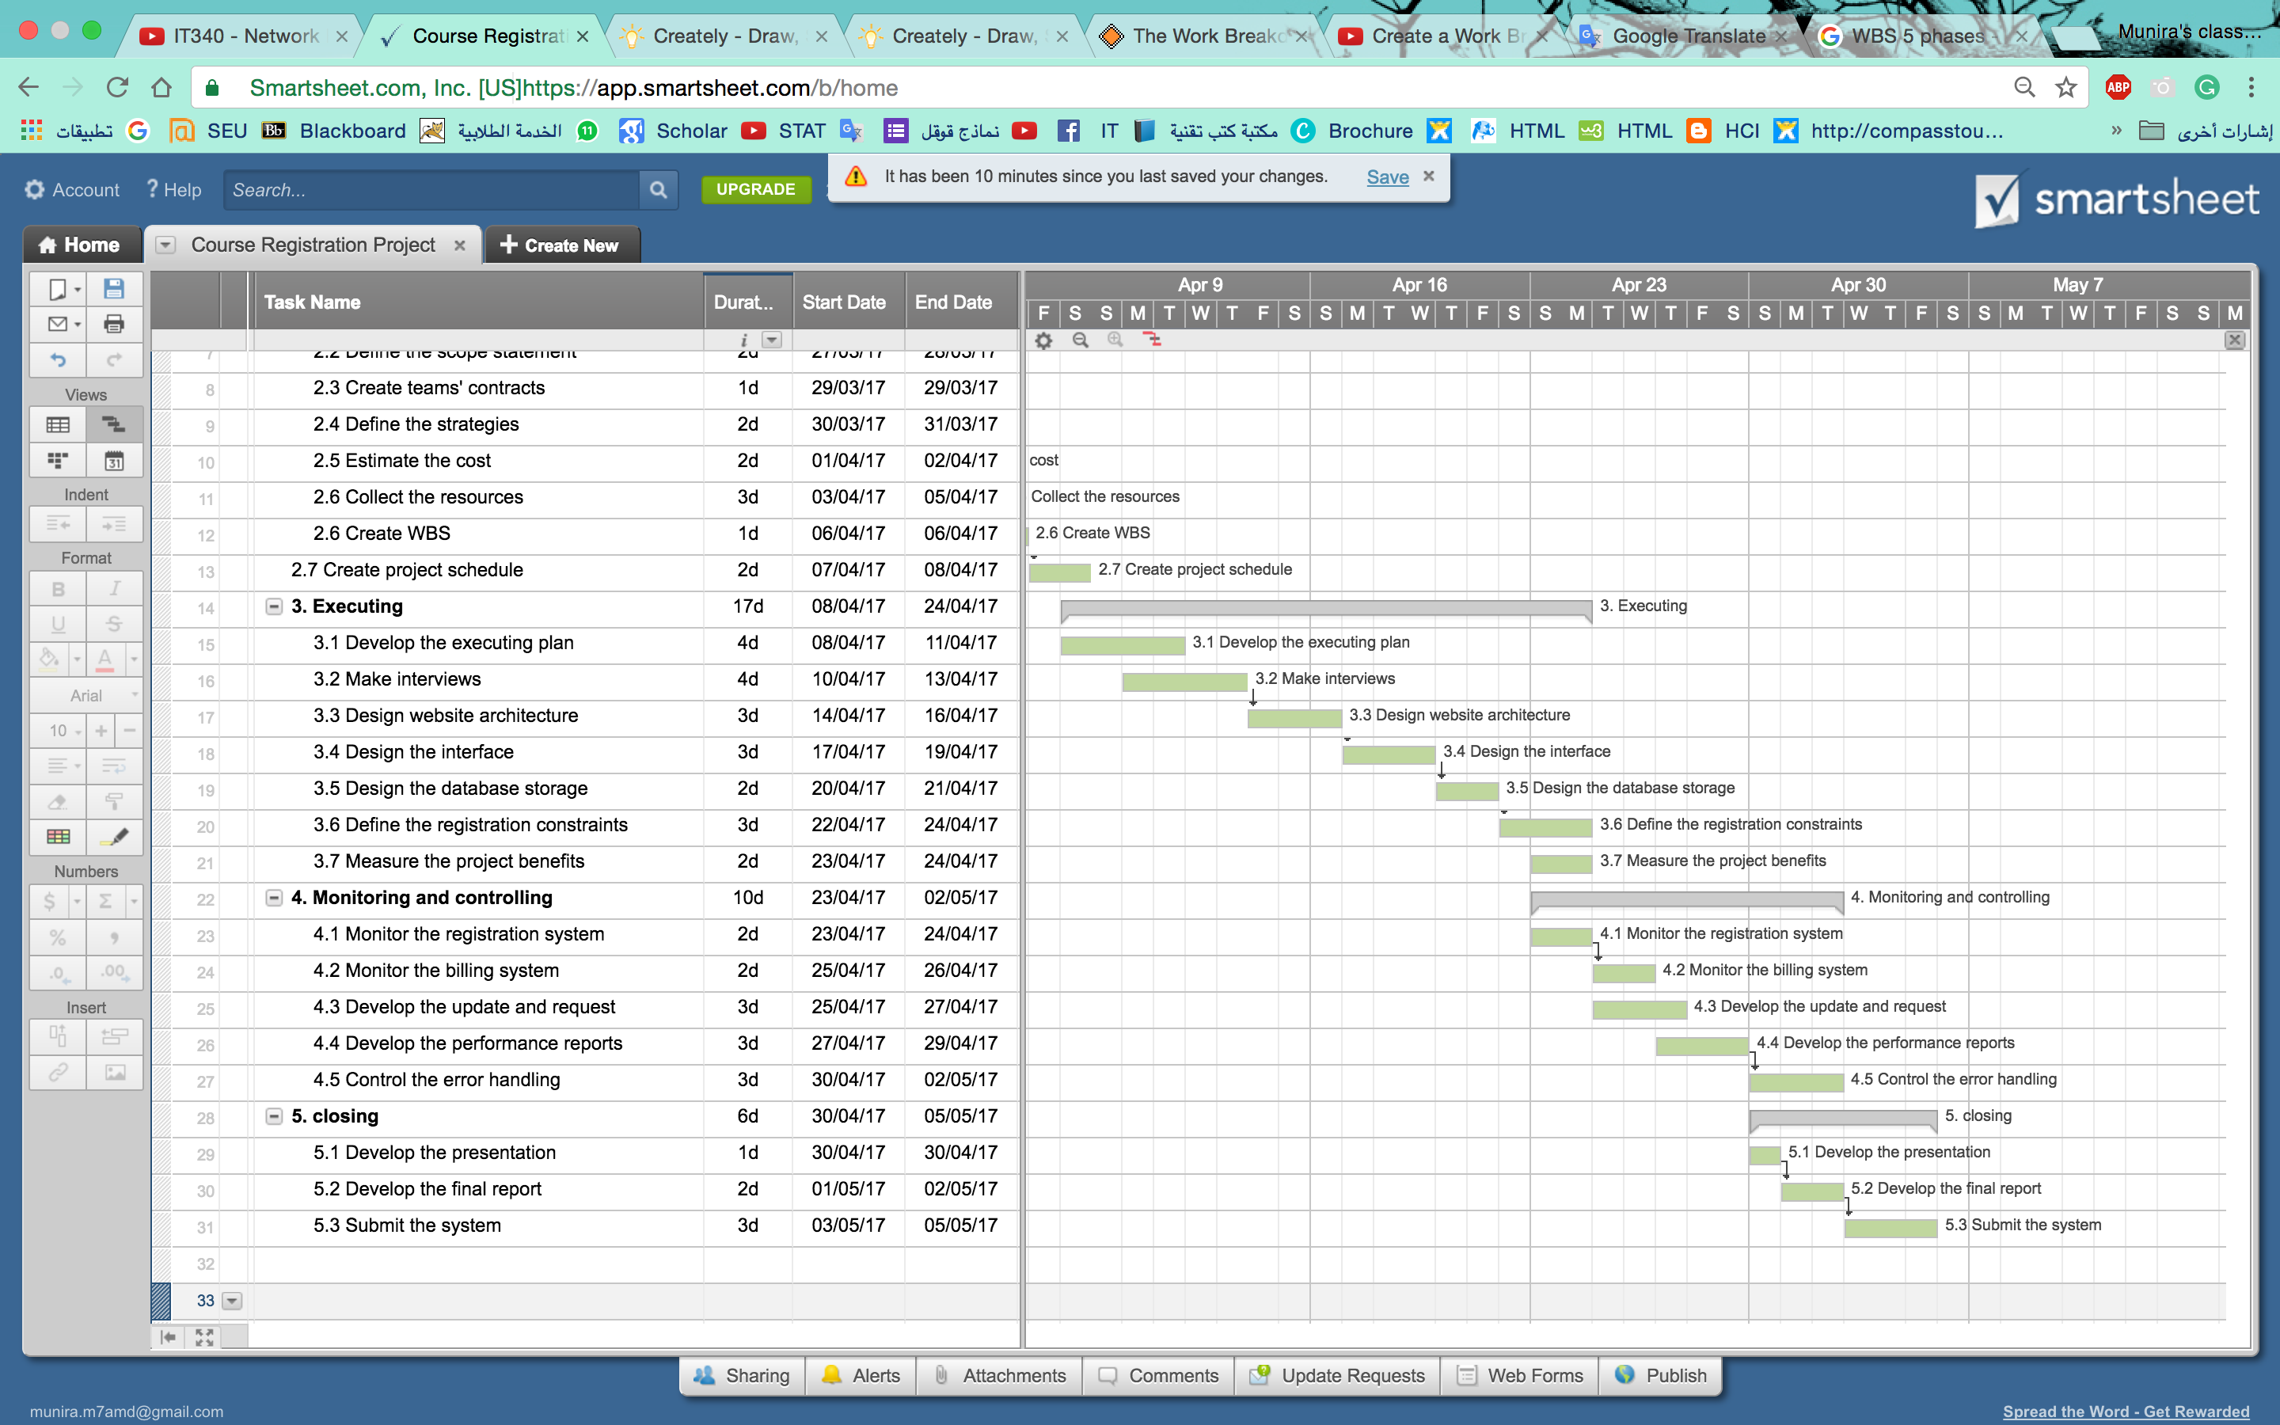

# Question Two

***1 Marks***

*Learning Outcome(s):*

* Explain the strategic planning process and why it is important.
* Review an organizational case study which incorporates elements for managing a project from start to finish.
* Identify the elements used when developing project management plans.
* Describe the tools and techniques used for directing and implementing projects.

Using a mind mapping software create a mind map of a SWOT analysis for the “*Course Registration Project*”, including at least two strengths, weaknesses, opportunities and threats.

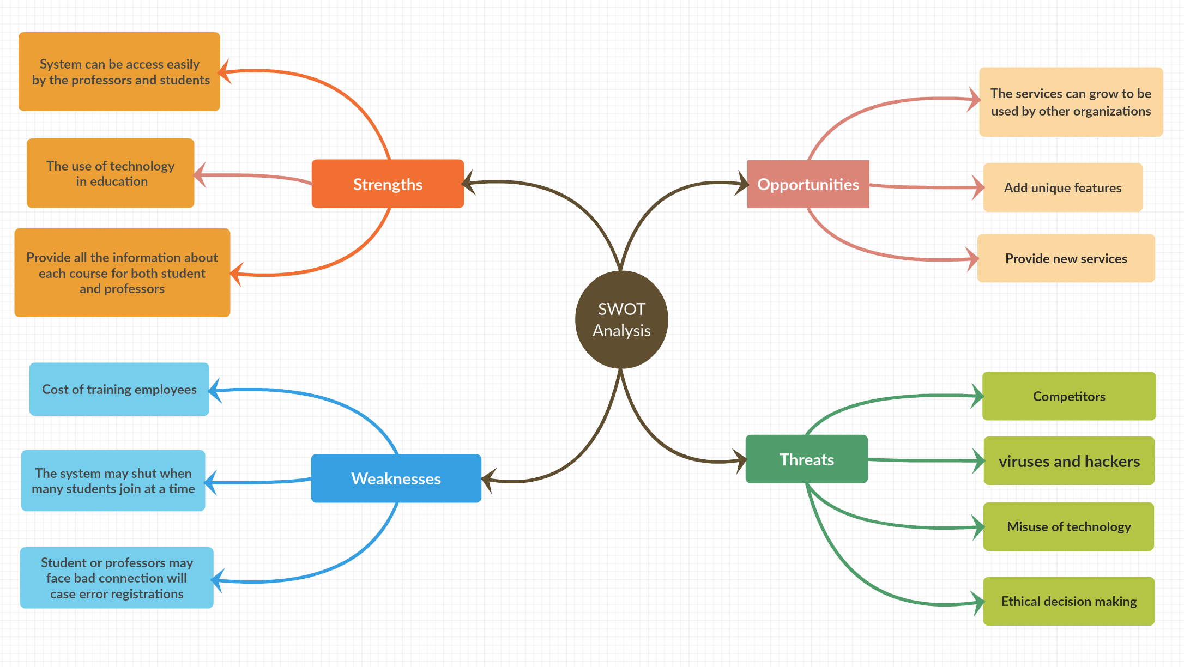

# Question Three

***1 Marks***

*Learning Outcome(s):*

* Describe the five project management process groups
* Discuss the varying nature by which project
* Review an organizational case study which incorporates elements for managing a project from start to finish.

List the key outputs of each process group in the “*Course Registration Project*”.

**Initiating outputs**:

* Determining the stakeholders and the responsible manager
* The project charter

**Planning outputs:**

* Requirements
* Schedule and strategies.
* Teams’ contracts
* Recourses

**Executing outputs:**

* Plan has been determined
* Website prototype
* Constraints built

**Monitoring and controlling outputs:**

* Billing system
* Updates and errors handling are considered.